TO implement 2 bit half adder using nand gates:

Diagram:-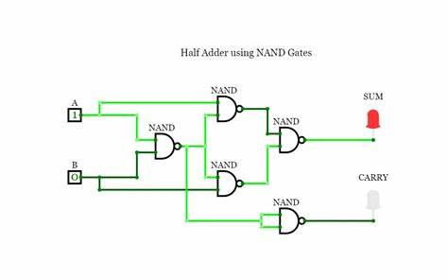

TRUTH TABLE:-

|  |  |  |  |
| --- | --- | --- | --- |
| A | B | SUM | CARRY |
| 0 | 0 | 0 | 0 |
| 0 | 1 | 1 | 0 |
| 1 | 0 | 1 | 0 |
| 1 | 1 | 0 | 1 |